**DATA ANALYTICS**

**UNLEASHING THE POWER OF THE YOUTH: A STUDENT PERFORMANCE ANALYSIS**

TEAM LEADER:

P.M.SHRUDHISHREE

TEAM MEMBERS:

TEJASWINI NAGARAJ

K.VIJAYALAKSHMI

L.HUSNA

C.PAVANI

PROJECT REPORT

1. INTRODUCTION
   * OVERVIEW

**Unleashing The Potential Of Our Youth: A Student Performance Analysis**

A country's growth is strongly measured by quality of its education system. Education sector, across the globe has witnessed sea change in its functioning. Today it is recognized as an industry and like any other industry it is facing challenges, the major challenges of higher education being decrease in students' success rate and their leaving a course without completion. In this project we will be analysing the data of the student and gives the clear cut analysis of the students performance in the exam.

Technical Architecture:

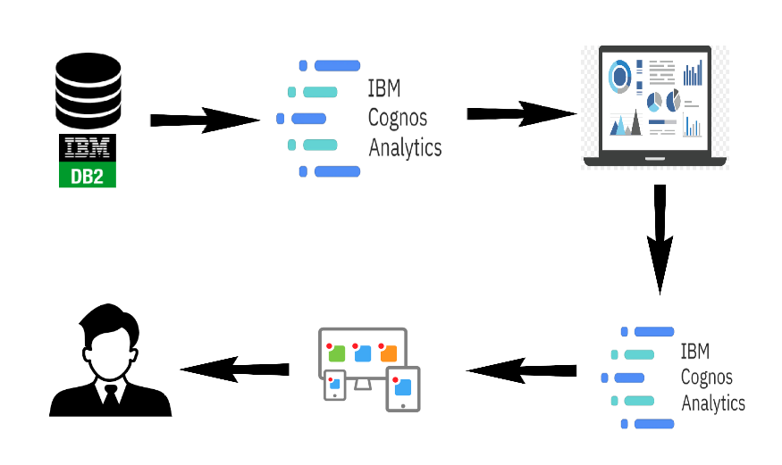

* + PURPOSE
    1. Identifying the strength and the weakness of the students and identifying in which areas they are excelling and which areas they are lacking.
    2. By monitoring student performance regularly, educators can identify students who may be at risk of falling behind or facing academic challenges early on.
    3. Advanced analytics in IBM Cognos can enable educators to predict future performance trends and identify factors that may influence student outcomes. This can help in devising proactive strategies to enhance overall student success.
    4. The reports ,visualizations ,story and the dashboard can give a clear cut idea on the overall performance analysis as a whole or in a respective version that can be useful to us.
    5. This allows for timely interventions and support to help these students get back on track

1. LITERATURE SURVEY
   * EXISTING PROBLEMS

* The basic problems that are faced here is that a lot of data are available ,that is 1000 members of data can’t be accessed individually
* Even though we have the data those are not segregated according to the needs of the mentors who are educating the students
* If the students lacked in some of the subjects we do not know the specific reason for their poor performance
* In the data set I have given there are some data which needed to be processed for some better understanding of the situation
* At last the major problem is that the student must be able to understand his progress by the data ,but the unprocessed data cant give him a scope
  1. PROPOSED SOLUTIONS
* Develop targeted intervention strategies based on analysis findings. Implementing specific programs for struggling students, such as tutoring, mentoring, or additional resources, can enhance their academic performance.
* Present analysis results using interactive and visually engaging data visualizations. Visual storytelling can help stakeholders better understand the data, enabling them to make informed decisions.
* Use analysis insights to develop personalized learning plans for students. Tailoring educational content and strategies to individual student needs can improve engagement and outcomes.
* Develop real-time reporting and interactive dashboards that enable educators and administrators to monitor student performance continuously. This allows for timely decision-making and intervention strategies
* Implement data quality assurance processes to identify and address data inconsistencies, errors, and missing values.

1. THEORITICAL ANALYSIS

3.1 BLOCK DIAGRAM

de

STORY

REPORT

DEFINE PROBLEM /PROBLEM UNDERSTANDING

DASHBOARD

PROJECT DEMONSTRATIONAND DOCUMENT

DATA VISUALIZATION

DATA PREPARATION

WEB INTEGRATION

DATA COLLECTION

3.2 HARDWARE AND SOFTWARE DESIGNING

1. Software like MySQL, PostgreSQL, or Microsoft SQL Server to store and manage student data securely.
2. Data analytics by using the IBM Cognos and also by using the python matplotlib for creating insights .
3. IBM COGNOS is a web based integrated business intelligence suite by ibm cognos. It is a tool set for reporting and analysing the data that is given to us
4. Jupyter notebook for interactive analysis and exploration
5. Visual studio code for a comprehensive code and development and debugging environment

SOFTWARE REQUIREMENTS

* Solid State Drive (SSD) is recommended for faster data access and overall system responsiveness. It can significantly improve loading times for software
* Ensure a stable internet connection if the project involves cloud-based services, online collaboration, or data transfers. data.

1. RESULT

DASHBOARD:

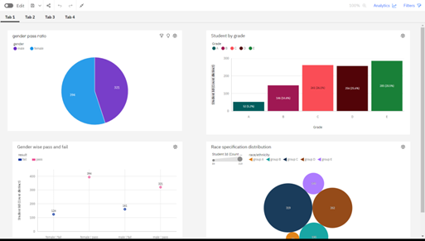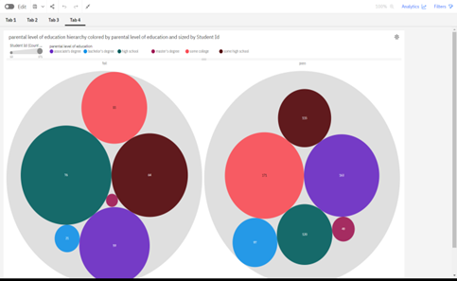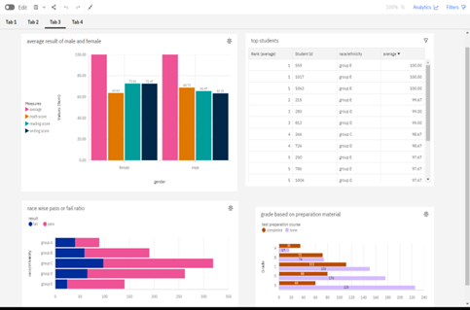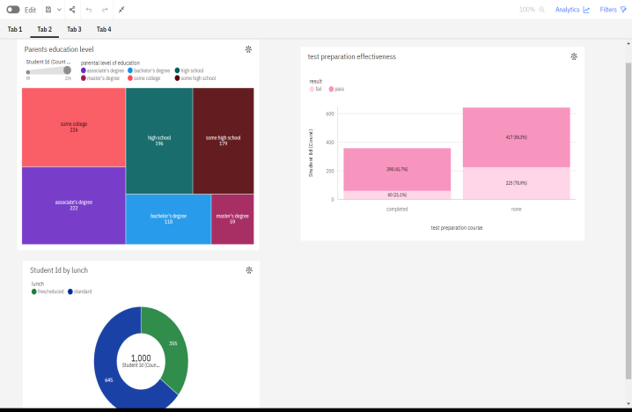

STORY

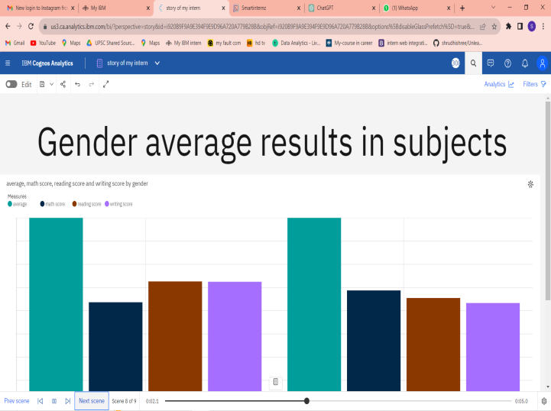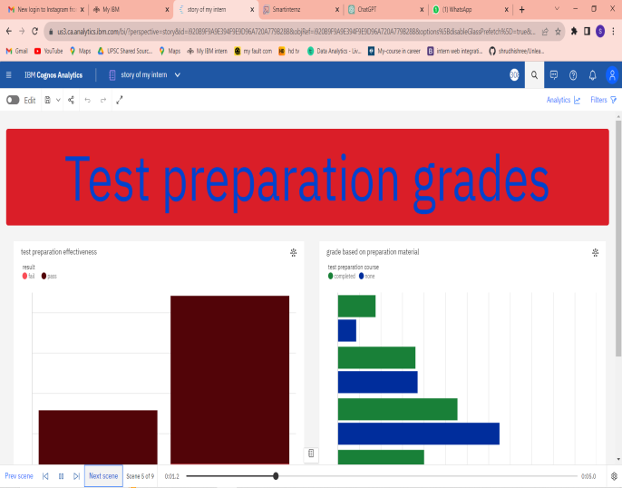

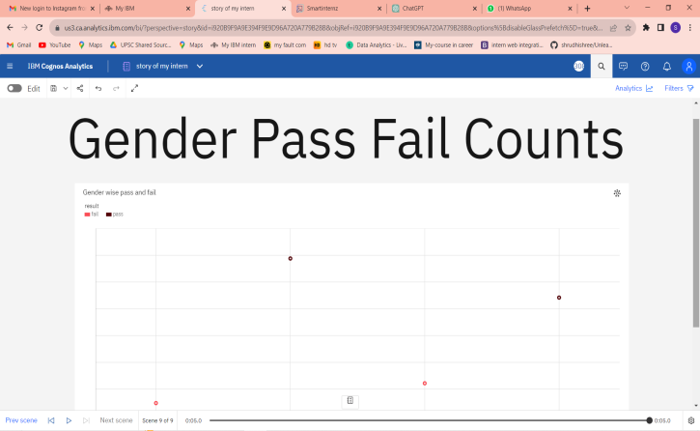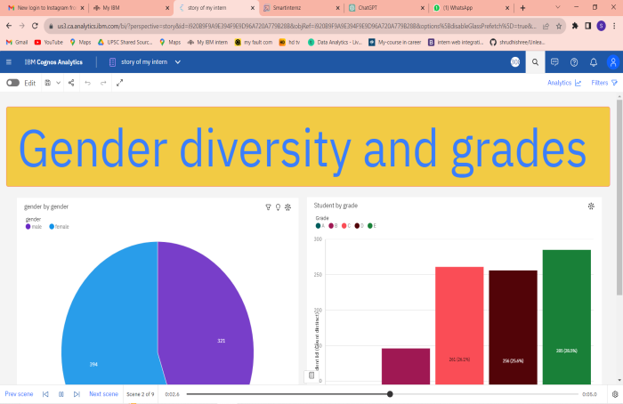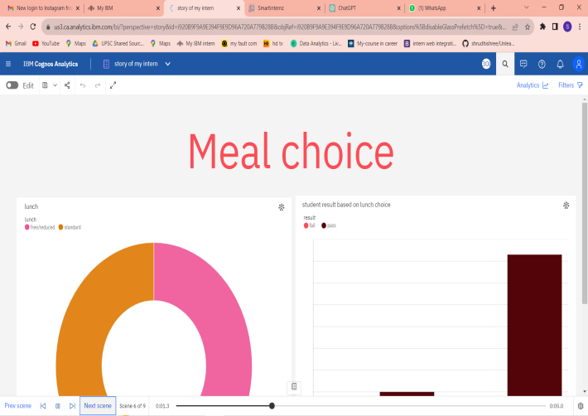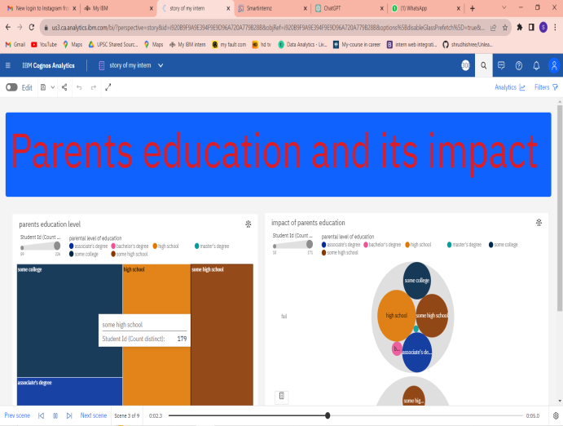

REPORT

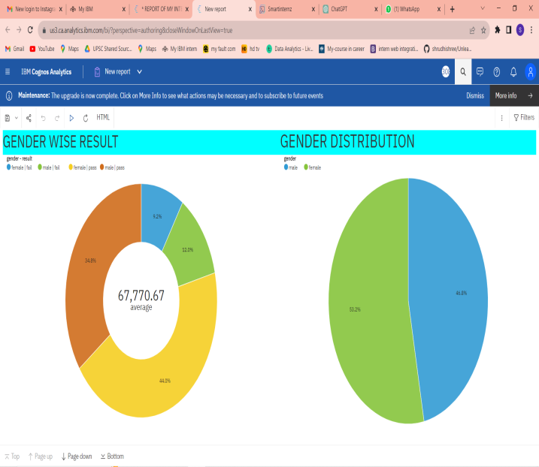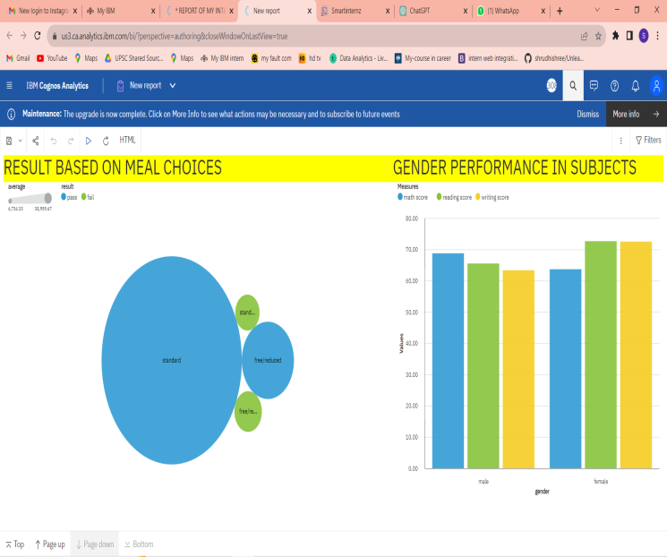

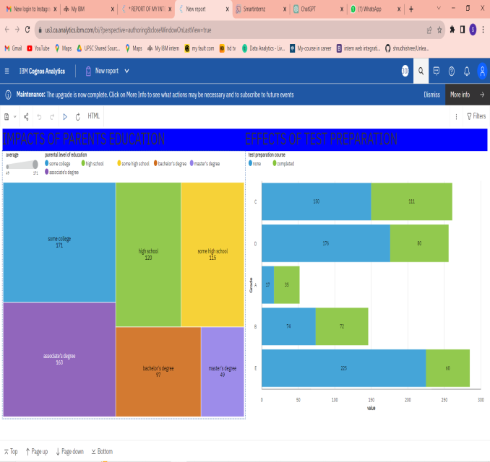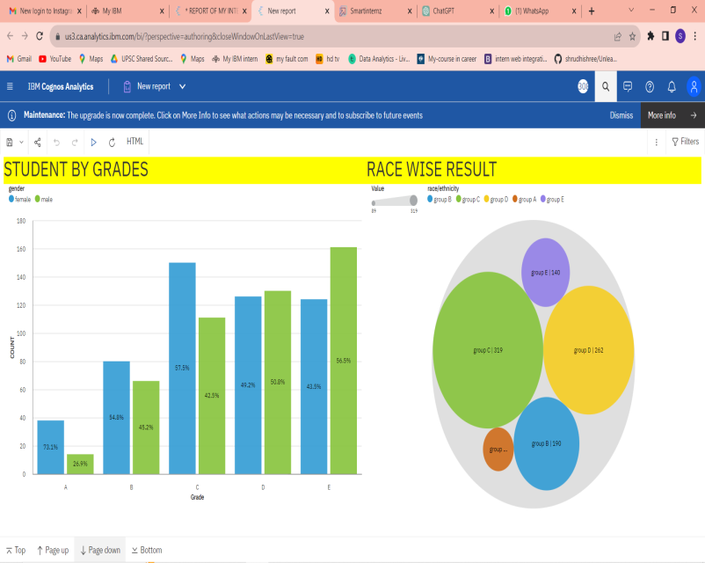

1. ADVANTAGES AND DISADVANTAGES

Advantages

* Fresh perspectives:

Young minds bring innovative ideas and new approaches to problem-solving, leading to more creative and effective solutions in student performance analysis.

* Technological prowess:

The youth are often tech-savvy and can leverage the latest tools and technologies to enhance data collection, analysis, and presentation in performance evaluations.

* Adaptability:

Students are more adaptable to changes in education systems, making it easier to implement new assessment methods and adapt to evolving learning environments.

* Increased engagement:

Involving students in the analysis process can boost their motivation and engagement with their own academic progress, leading to better self-awareness and ownership of their learning journey.

Disadvantages

* Inexperienced students may struggle to grasp the full complexity of performance analysis, potentially leading to oversimplification or misinterpretation of data.
* Students might bring their personal biases into the analysis, affecting the objectivity and reliability of the results.
* Involving students in performance analysis can be time-consuming, potentially taking away valuable learning time from their academic pursuits.
* Handling sensitive data about their peers can raise ethical concerns regarding privacy and confidentiality.
* To effectively unleash the power of the youth in student performance analysis, a balanced approach that combines their insights with experienced educators or professionals is recommended.

1. APPLICATIONS ON THE PROJECT

The concept of unleashing the power of the youth in student performance analysis has various applications in the field of education. Some of the key applications include:

Allowing students to actively participate in the assessment process can foster a sense of responsibility and ownership over their own learning outcomes. This can be done through self-assessment, peer assessment, or student-led conferences with teachers and parents.

Students' insights on their learning experiences and preferences can be valuable in refining and designing curriculum content that is more relevant, engaging, and effective.

Students can be involved in research projects related to their own academic performance, contributing to educational research and providing valuable insights for educators and policymakers.

Young minds can be instrumental in developing educational technology tools and applications that cater to their learning needs and enhance student performance analysis.

By involving students in analyzing school-wide performance data, educators can identify areas for improvement in teaching methods, school policies, and resources to create a more conducive learning environment.

Engaging students in performance analysis can encourage open communication between students, teachers, and parents, leading to a deeper understanding of academic progress and shared goal-setting.

Students can use performance analysis to identify career interests, strengths, and weaknesses, helping them make informed decisions about their educational and career paths.

Involving students in performance analysis empowers them to take an active role in shaping their educational experiences and can nurture leadership skills.

Overall, the applications of unleashing the power of the youth in student performance analysis can lead to a more student-centered, inclusive, and effective educational ecosystem.

1. CONCLUSION

Unleashing the power of the youth through student analysis is a transformative and empowering endeavor that holds immense potential for shaping a brighter future.

By harnessing the insights and capabilities offered by data-driven student analysis, we can unlock a wealth of opportunities to nurture and support the next generation of leaders, innovators, and changemakers

In conclusion, student analysis provides us with the means to understand individual learning journeys, identify strengths, address weaknesses, and personalize education to suit each student's unique needs. It enables educators and policymakers to make informed decisions that positively impact student outcomes and foster a culture of continuous improvement.

Moreover, student analysis offers a pathway to promoting inclusivity and equity in education. By recognizing disparities and addressing them proactively, we can create a level playing field for all students, regardless of their backgrounds or circumstances.

As we unleash the power of the youth through student analysis, it is essential to remain committed to ethical considerations, safeguarding student privacy, and ensuring data security at all stages of the process.

In embracing data-driven decision-making, we set the stage for a future where every student is given the opportunity to reach their fullest potential and make meaningful contributions to society. By investing in student analysis, we invest in the promise of a brighter, more inclusive, and prosperous tomorrow.

1. FUTURE SCOPE

The future scope of unleashing the power of youth through student analysis is promising and far-reaching. As technology and data analytics continue to advance, student analysis will play an increasingly significant role in shaping the education landscape and empowering the next generation of learners. Here are some potential future developments and opportunities:

Student analysis will enable the widespread implementation of personalized learning, tailoring education to the individual needs, strengths, and learning styles of each student. Advanced machine learning algorithms will deliver personalized content, adaptive assessments, and real-time feedback, optimizing the learning experience.

Future student analysis will extend beyond academic performance to assess students' social, emotional, and psychological well-being. This comprehensive approach will help create a supportive and nurturing environment that fosters holistic student development.

Student analysis will foster global collaboration among educators, researchers, and policymakers. Sharing anonymized data and research findings across borders will lead to a deeper understanding of educational challenges and innovative solutions.

As students become more data-literate, they will actively participate in their educational journey. Student analysis will empower learners to set personalized goals, track their progress, and take ownership of their learning outcomes.

Student analysis will be instrumental in addressing learning inequalities and closing the achievement gap. It will enable targeted interventions and equitable access to quality education for all students, regardless of socio-economic backgrounds.

Student analysis will benefit from interdisciplinary collaboration, combining educational expertise with fields like neuroscience, psychology, and cognitive science. This cross-disciplinary approach will deepen our understanding of effective learning strategies and cognitive processes.

In the future, unleashing the power of youth through student analysis will continue to be a driving force in transforming education, fostering innovation, and nurturing a generation of empowered, well-rounded, and future-ready individuals. Embracing the potential of data-driven education will open up new frontiers of possibilities, ensuring a more inclusive, equitable, and prosperous future for all learners.

**THANKING YOU**

